UDACITY

**Introduction to Generative AI with AWS**

**Project Documentation Report**

Visit [UDACITY Introduction to Generative AI with AWS Project Documentation Report](https://docs.google.com/document/d/1kqRy-gVGZjwl9r03hqMeWSm-D6hEY8KWuxz4GO0vdOw/copy) to make a copy of this document.

Complete the answers to the questions below to complete your project report. Create a PDF of the completed document and submit the PDF with your project.

|  |  |
| --- | --- |
| Question | Your answer: |
| **Step 2: Domain Choice**  What domain did you choose to fine-tune the Meta Llama 2 7B model on?  Choices:   1. Financial 2. Healthcare 3. IT | Healthcare |
| **Step 3: Model Evaluation Section**  What was the response of the model to your domain-specific input in the **model_evaluation.ipynb file**? | Myeloid neoplasms and acute leukemias derive from  > the bone marrow and are often referred to as hematologic malignancies.  There are many different types of myeloid neoplasms and acute leukemias. The most common are:  Chronic myeloid leukemia (CML) is a type of  ================================== |
| **Step 4: Fine-Tuning Section**  After fine-tuning the model, what was the response of the model to your domain-specific input in the **model_finetuning.ipynb file**? | Myeloid neoplasms and acute leukemias derive from  > [{'generated_text': ' hematopoietic stem and progenitor cells (HSPCs) that undergo clonal expansion and differentiation.\nHSPCs are found in the bone marrow and are responsible for blood production. HSPCs are composed of hematopoietic stem cells (HSC'}]  ================================== |

**Pre-trained Model Evaluation**

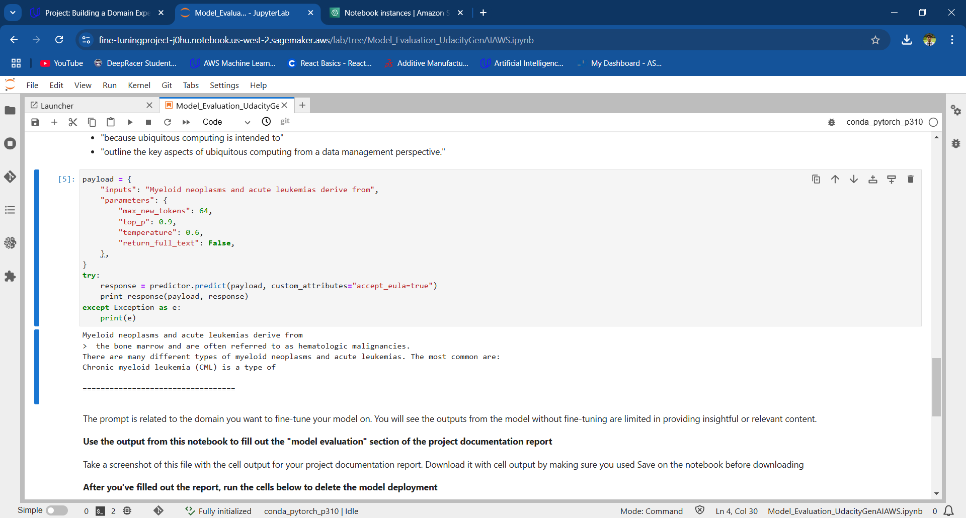

Screenshot of the pre-trained model deployed in the SageMaker environment

**Evaluate the Fine-tuned Llama2 Large Language Model**

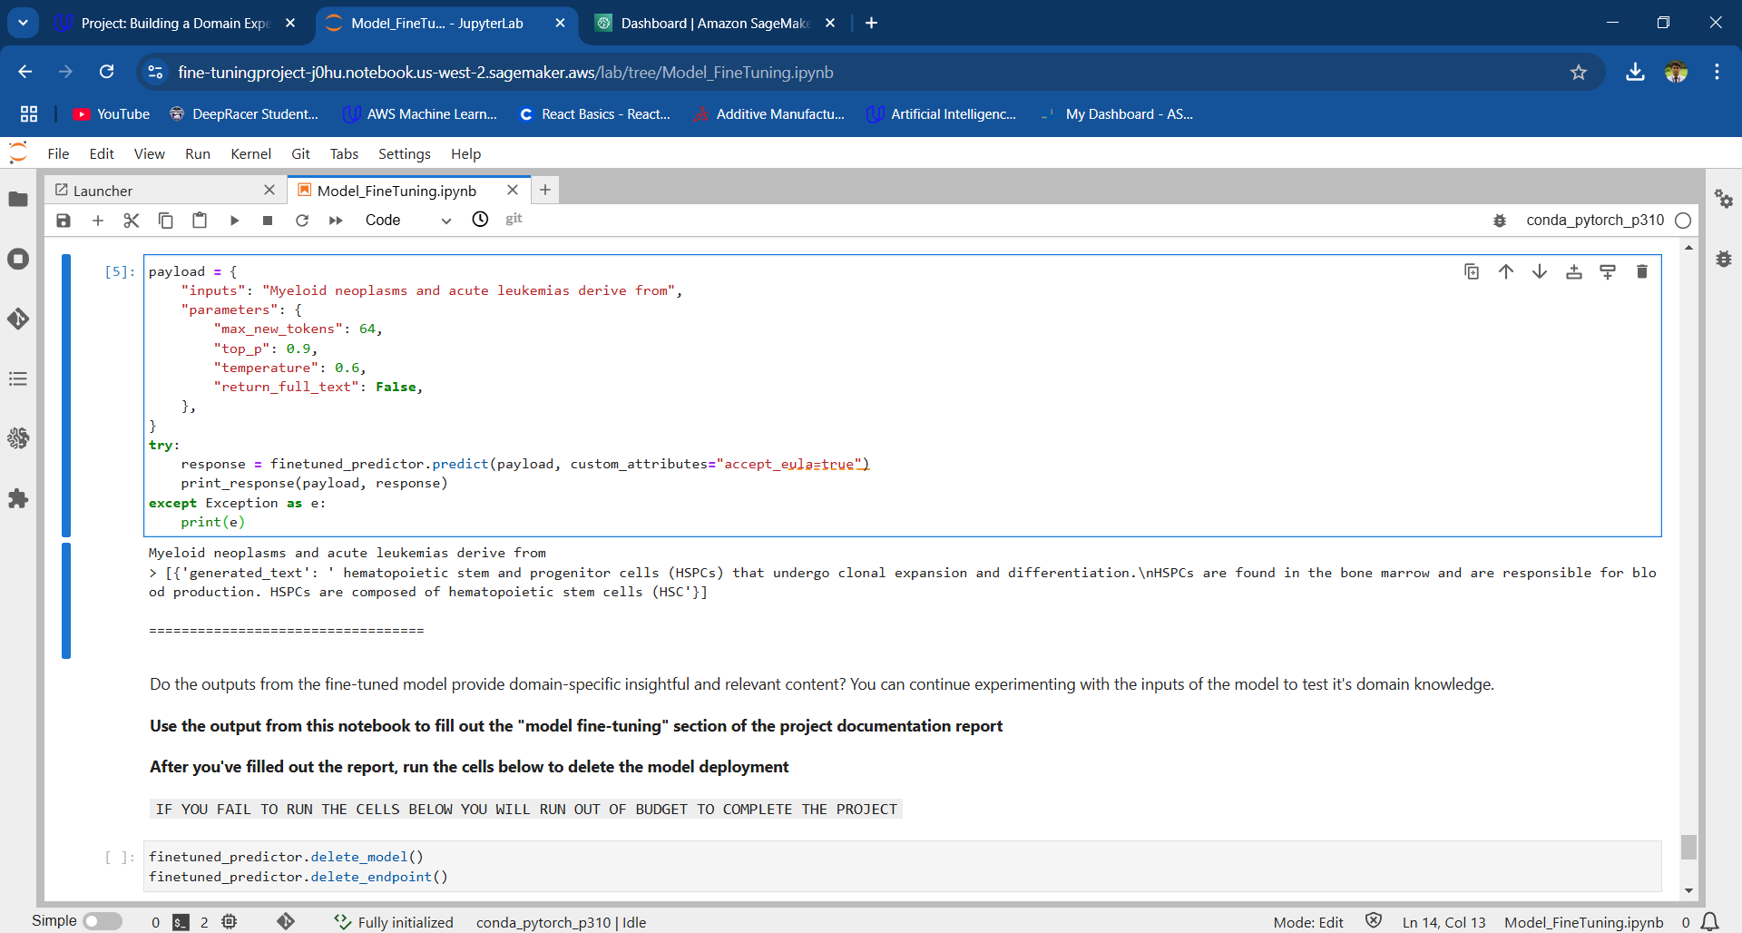

Screenshot of the fine-tuned model deployed in the SageMaker environment